**Use case Analysis Diagrams for Online Car Rental Management System Project**

1. **Sequence Diagrams**

**1.0 Reservation**

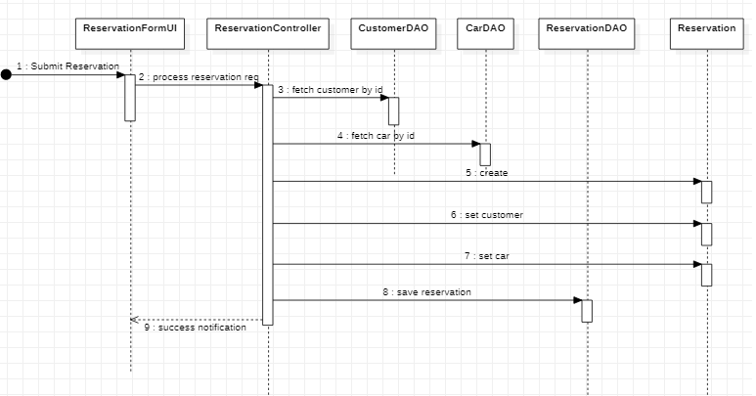

1.1 Checkout

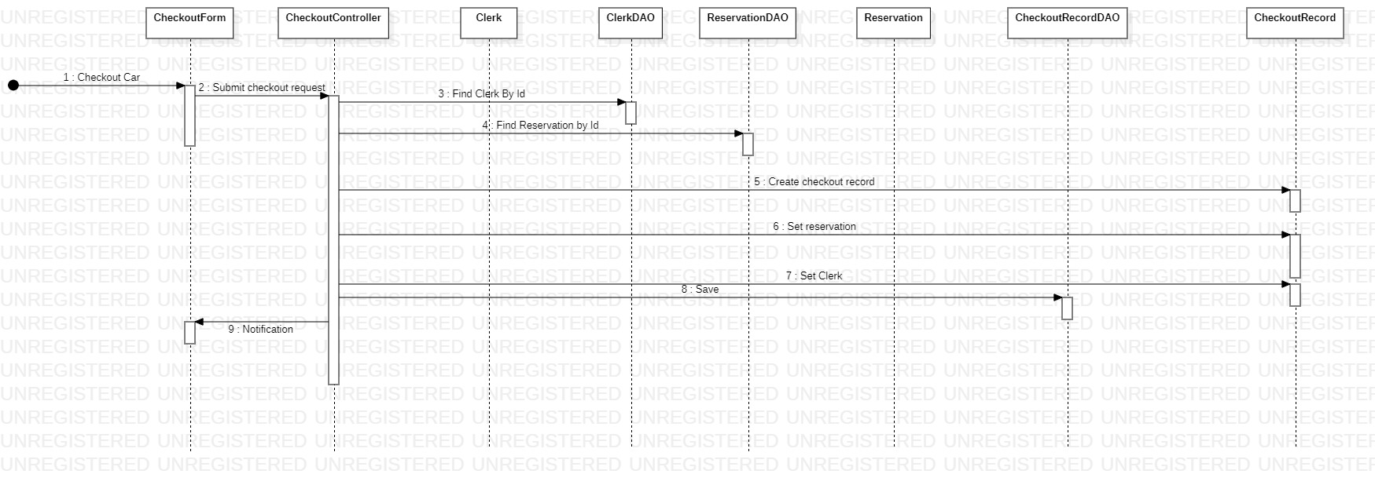

1. VOPC Diagram

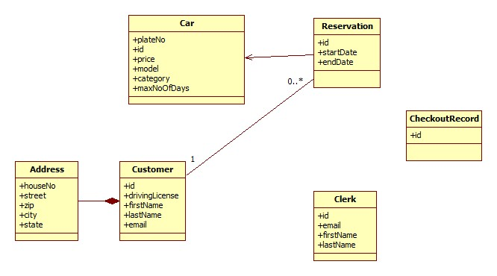

1. Collaboration Diagrams

3.0 Car-checkout-collaboration-diagram

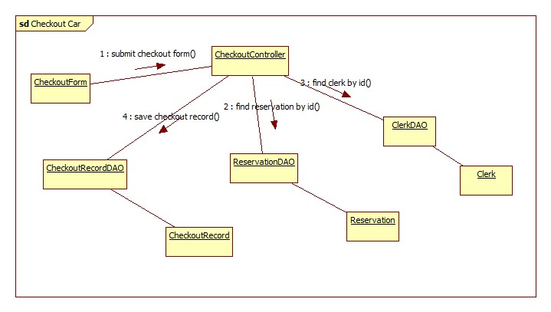

3.1 Car-reservation-collaboration-diagram

